Digital 6000 wireless microphones have their maritime debut
Sennheiser equipment has been an integral element on board the AIDA fleet for more than 20 years

Wedemark, 21 June 2018 – The entertainment programme on board the AIDA cruise ships is increasingly becoming the domain of Sennheiser Digital 6000 systems. In April 2017, the AIDAvita became the first member of the fleet to be equipped with the audio specialist’s ground-breaking wireless systems. In the meantime, it has been followed by the AIDAcara and AIDAblu. The AIDAaura was fitted out with Digital 6000 systems in April 2018 during its scheduled maintenance stop in the shipyard. The AIDAstella and AIDAbella will benefit from Sennheiser’s pioneering wireless solution later this year.

“We are planning to equip the entire AIDA fleet with Sennheiser Digital 6000 systems in the near future,” said Daniel Hobucher, who, as Supervisor Sound Technology at AIDA Cruises, is responsible for the complete fleet, from the AIDAcara to the AIDAnova, which is currently being built. Today, twelve AIDA cruise ships are criss-crossing the oceans, and the aim is to standardise the audio equipment throughout the fleet, which has grown steadily over the years. “We want to avoid having any stand-alone solutions because our technicians move from one ship to another and they need to be able to find comparable working conditions wherever possible,” Hobucher added.

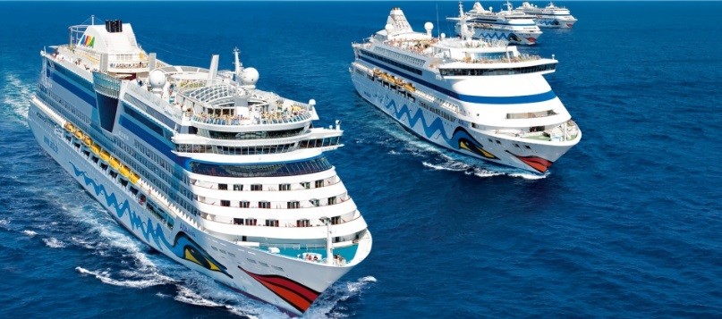 | The entertainment programme on board the AIDA cruise ships is increasingly becoming the domain of Sennheiser Digital 6000 systems  © AIDA Cruises

Digital 6000 on all decks
The theatre on the AIDAcara will be equipped with nine Sennheiser EM 6000 two-channel receivers, along with fourteen SK 6000 bodypack transmitters and thirteen SKM 6000 handheld transmitters. The handheld transmitters are fitted with cardioid MD 9235 or super-cardioid ME 9005 capsules. The bodypack transmitters are operated with high-quality Sennheiser headset microphones (HSP 4, HSP 2) and professional clip-on microphones of the MKE series. While the theatre on the AIDAvita uses comparable equipment, the larger AIDAblu employs a total of 20 Sennheiser two-channel receivers, which are distributed around different areas of the ship, such as the Theatrium, the pool deck, the AIDA Bar, the Brauhaus and various smaller event locations.

Daniel Hobucher, Supervisor Sound Technology at AIDA Cruises | 

Daniel Hobucher is highly impressed by the user-friendly battery technology of the Sennheiser Digital 6000 systems: “At the moment, we’re in the process of putting the rechargeable batteries through their paces, and so far we haven’t noticed any problems at all. The battery life is more than sufficient, and the indication of the remaining battery life is very reliable. The battery packs are stored in sufficient numbers on board. A special feature is the 19” format of the charging units. There is very limited space available on the ships, and the charging units that were previously used for the BA battery packs were not the optimum solution for us for this reason. The flatter L 6000 charging stations in their rack format with only 1 U are a definite improvement!”

The innovative Sennheiser Digital 6000 systems are operated on board in parallel with proven analogue Sennheiser in-ear channels, which, according to Daniel Hobucher, “works absolutely brilliantly”. After the new equipment was installed, members of the show ensemble expressed the view that they could hear their voices much more directly and clearly thanks to the new Sennheiser transmitters. Some performers pointed out that the luxurious SKM 6000 handheld transmitters were slightly heavier and bigger than the predecessor models, and this was generally seen to be a positive aspect. “Most performers are very happy to work with the new transmitters from the Digital 6000 series, and the sound engineers are also more than satisfied and report of an improved presence for the voices and a better sound overall,” said Daniel Hobucher, summing up the comments on the extremely good performance of the new equipment on board.

SKM 6000 handheld transmitters are used on the show stage | 

Sennheiser and AIDA: a partnership that goes back decades
Wireless systems from Sennheiser have been a fixed component of the audio equipment on board the AIDA fleet for more than two decades. The AIDAcara, the first ship of the well-known fleet to be launched, originally used EM 3032 receivers with SK 3063 bodypack transmitters (16 switchable carrier frequencies). On the AIDAvita, the equipment previously used included EM 3532 two-channel receivers, while the AIDAaura used EM 3732 and EM 3532. The Theatrium on the AIDAblu was equipped with EM 3732-II, while on the pool deck and in other areas, EM 550 G2 twin receivers did their job in challenging conditions.

 | The SKM 6000 handheld transmitters are operated with MD 9235 or ME 9005 capsules

“We have been working with Sennheiser for more than 20 years now and have always experienced this company to be a reliable partner,” said Daniel Hobucher. “The quality of the products is superb, which also applies to the finish as well as to the sound. The ordering process and the repairs – which are rarely necessary – are uncomplicated. There is always a direct contact person available who comes to our assistance whenever the need arises.”

Reliable on every route
The use of ground-breaking Sennheiser Digital 6000 systems relieves the crew of any problems with wireless interference. “Ever since the Digital 6000 systems were installed on board, we have no longer heard of any complaints whatsoever in this respect,” reported Daniel Hobucher. Even in the outside areas such as the pool deck, which tend to be particularly sensitive to transmission interference, everything works perfectly.”

As the ships of the AIDA fleet are registered under an Italian flag, the ships are legally speaking Italian territory. “Our ships are basically subject to Italian maritime law – also regarding the use of wireless frequencies,” explains Daniel Hobucher. “With a view to the effects of the Digital Dividend, we have decided to go as low as possible within the UHF range. We work with our Digital 6000 systems on all ships in the frequency range between 470 and 558 MHz, which corresponds to the Sennheiser frequency groups A1 to A4. In the past, we weren’t always able to select suitable segments as an alternative due to the smaller switching bandwidth. The Sennheiser Digital 6000 series, on the other hand, is always reliable on every route.”

About Sennheiser
Sennheiser is shaping the future of audio – a vision built on more than 70 years of innovation culture, which is deeply rooted within the family-owned company. Founded in 1945, Sennheiser is one of the world’s leading manufacturers of headphones, microphones and wireless transmission systems. With 20 sales subsidiaries and long-established trading partners, the company is active in more than 50 countries and operates its own production facilities in Germany, Ireland and the USA. Sennheiser has around 2,800 employees around the world that share a passion for audio excellence. Since 2013, Sennheiser has been managed by Daniel Sennheiser and Dr. Andreas Sennheiser, the third generation of the family to run the company. As part of the Sennheiser Group, the joint venture Sennheiser Communications A/S is specialized in wireless and wired headsets and speakerphones for contact centers, offices and Unified Communications environments as well as headsets for gaming and mobile devices. In 2016, the Sennheiser Group had sales totaling €658.4 million. www.sennheiser.com

Local Press Contact Global Press Contact

Stefan Peters Stephanie Schmidt
stefan.peters@sennheiser.com stephanie.schmidt@sennheiser.com
+49 (5130) 600 – 1026 +49 (5130) 600 – 1275

